Day -2 Tasks

1. Receive Name and Age of the person and display the name age number of times. That is if the age is 50 the name should be displayed 5o times.
2. For the given number display the multiplication table upto the number into 20 times and the result should be in the following format:

N * 1 = N

N * 2 = 2N

\

N*20 =20N

1. **Write a program to give the rates for the selected TV Channel Package based on the following: (Use Switch to calculate)**

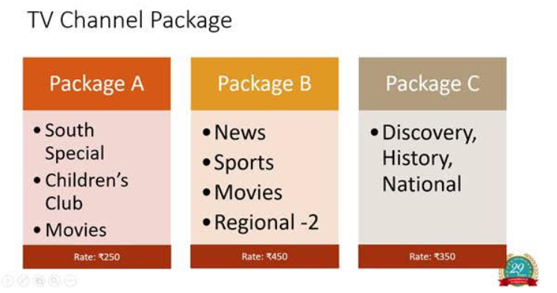

1. A student has 5 subjects. Create an array to store the marks and find the tot and percentage.
2. **Write a Program to maintain the product list under the following categories:**

|  |  |  |
| --- | --- | --- |
| List | Product Category | No of Items |
| a. | Biscuits | There are 4 items |
| b. | Chocolates | There are 5 items |
| c. | Drinks | There are 6 items |

**You may use Jagged array to achieve this**